**RESUME**

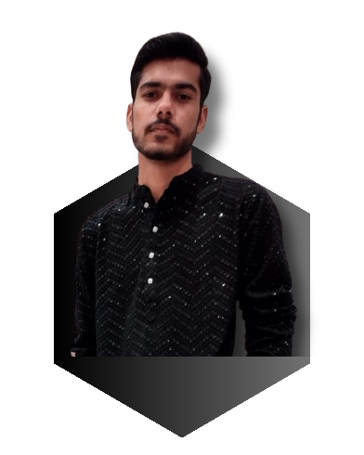

**Aman Pandey**

**Email Add: -** artaman068@gmail.com

**Mobile No.:** +91 9354787234

**Date of Birth:** 20th March 2005

**CAREER OBJECTIVE**

To work in a growth-oriented organization where I can utilize my skills and strengths for their growth. Where I can grow by enhancing my skills & knowledge as well.

**WORK EXPERIENCE**

|  |  |  |  |
| --- | --- | --- | --- |
| **Position** | **Organizations** | **Duration & Years** | **Location** |
| Teacher | IEIT Institute | Working since June 2022 | Shyam Vihar, New Delhi |
| Social Media Handling | Ieit Institute | Working since June 2022 | Shyam Vihar, New Delhi |
| Volunteer | Nischay Foundation | Working since 2022 | Shyam Vihar, New Delhi |
| Core Head | Tech-Samaaroh Event | In 2023 | TIPS, Dwarka, New Delhi |
| 3D Head | Apex (Designing Society Of TIPS) | Working since Oct. 2022 | TIPS, Dwarka, New Delhi |
| Executive Head | Cyber-Knight (Networking & Cyber Security Club of TIPS) | From Dec.2022- June 2023 | TIPS, Dwarka, New Delhi |
| Research Head | Cyber-Knight (Networking & Cyber Security Club of TIPS) | From June-2023 | TIPS, Dwarka, New Delhi |
| Joint Secretary | Apex (Designing Society Of TIPS) |  |  |

**SKILLS & STRENGTHS**

* Computer Skills
* Communication Skills
* Team player
* Quick learner
* Polite
* Consistent
* Thoughtful
* Presentation skills
* Teaching skills

**EDUCATIONAL QUALIFICATIONS**

|  |  |  |
| --- | --- | --- |
| **Degree/ Class** | **Board** | **Passing Year** |
| 12h | CBSE | 2022 |
| 10th | CBSE | 2020 |

**TECHNICAL COURSES**

|  |  |  |  |
| --- | --- | --- | --- |
| **Course** | **Training Institution** | **Duration &Year** | **Skill Learnt** |
| Active Basic IT | IEIT Institute | 3 Months (2022) | Computer Skills |
| Advanced Excel & | IEIT | 3 Months (2022) | Advance computer skills |
| Adobe Photoshop | Learn Tube | 3 Months(2023) | Basic |

**ACHIEVEMENTS**

* Awarded for getting the first position in-game event by the Shreshtha Bharat Foundation.
* Awarded with Corona Warrior Award by Nischay Foundation for supporting the weaker section during Lockdown.

**HOBBIES AND INTERESTS**

I Like to play games & learn new things. Helping needy people.

**Declaration:**

I hereby declare that all the above-mentioned details are correct as my Knowledge

**Date:-** 27/07/2023 **Aman Pandey**

“NOTE:- Certificates is on the next page”

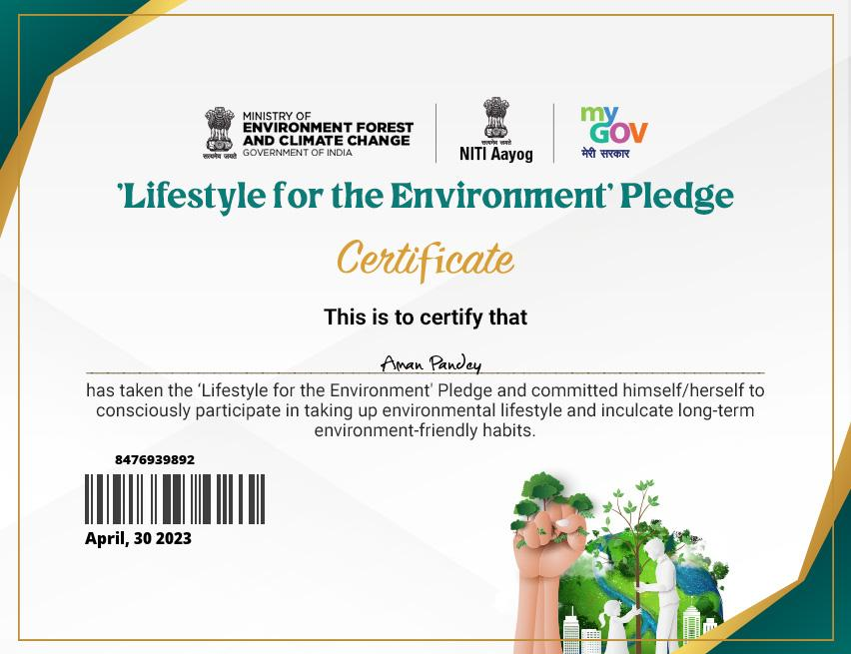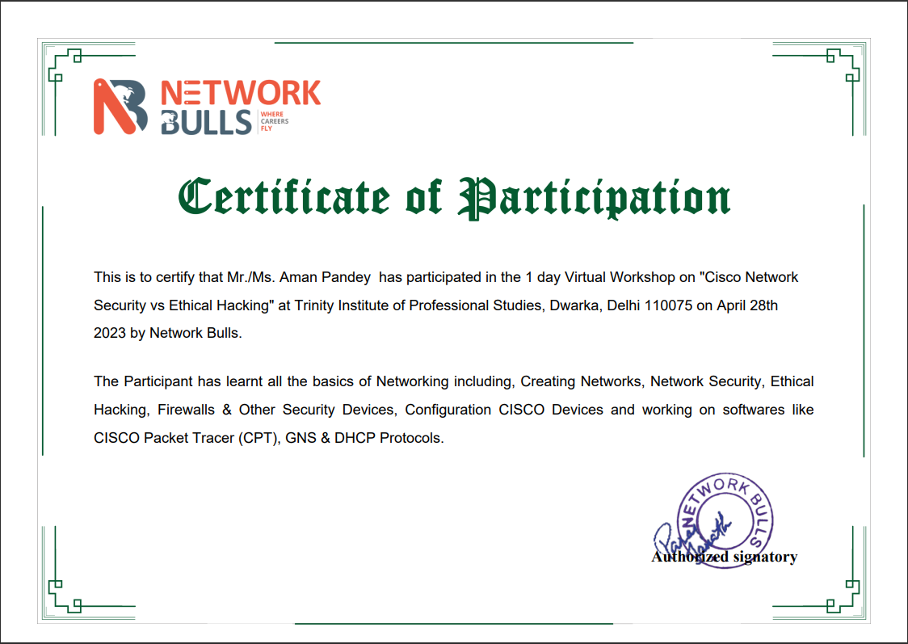Certificates

